Angola

## Political Stability Estimate Data

The data set shows the political stability estimate of the country each year.

## # A tibble: 19 x 5  
## country iso3c date stability stabilityCategory4   
## <chr> <chr> <dbl> <dbl> <chr>   
## 1 Angola AGO 1996 -2.06 highly unstable   
## 2 Angola AGO 1998 -2.31 highly unstable   
## 3 Angola AGO 2000 -2.04 highly unstable   
## 4 Angola AGO 2002 -1.58 highly unstable   
## 5 Angola AGO 2003 -1.01 highly unstable   
## 6 Angola AGO 2004 -1.06 highly unstable   
## 7 Angola AGO 2005 -0.888 moderately unstable  
## 8 Angola AGO 2006 -0.542 moderately unstable  
## 9 Angola AGO 2007 -0.666 moderately unstable  
## 10 Angola AGO 2008 -0.363 moderately unstable  
## 11 Angola AGO 2009 -0.347 moderately unstable  
## 12 Angola AGO 2010 -0.226 moderately unstable  
## 13 Angola AGO 2011 -0.369 moderately unstable  
## 14 Angola AGO 2012 -0.389 moderately unstable  
## 15 Angola AGO 2013 -0.391 moderately unstable  
## 16 Angola AGO 2014 -0.333 moderately unstable  
## 17 Angola AGO 2015 -0.501 moderately unstable  
## 18 Angola AGO 2016 -0.316 moderately unstable  
## 19 Angola AGO 2017 -0.295 moderately unstable

## Political Stability Estimate Plot

The plot shows the trends of stabilization and destabilization for the each country.

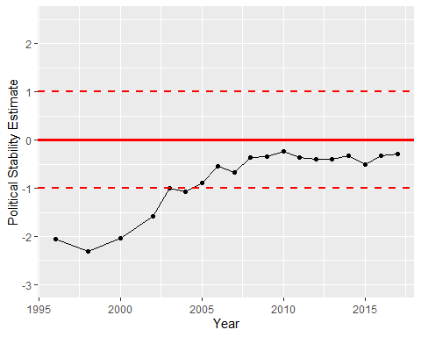

Political Stability Trend